State of Origin: Stem cells give new life to worn-out knees
May 25, 2014
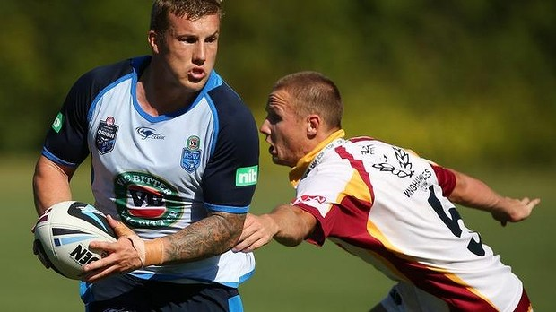
"I’ve felt a big difference. It hasn’t cured my knee but it’s certainly helped it out": Trent Hodkinson.
A $10,000 experimental medical procedure has helped saved the careers of two NSW players.
Stem cells placed into the knees of Trent Hodkinson and Aaron Woods have helped resurrect their careers and has allowed them to leap into the representative arena. They both had severe knee problems which could have forced them into early retirement. Hodkinson had the procedure in 2012, Woods at the end of last season.
Former long-term Wests Tigers doctor Donald Kuah performed the Regeneus HiQ procedure on Woods where a person’s own fat tissue – via liposuction – is injected into an affected joint or tendon.
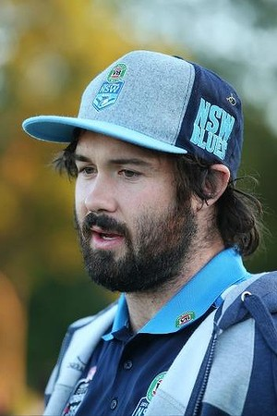
Grateful: Aaron Woods
The aim is to accelerate the regeneration of damaged cartilage. Kuah had no doubt Woods would have been forced into premature retirement had the operation failed. “He probably might’ve had cortisone injections which would last six weeks or so at a time,” Kuah said. “To be honest, he might be able to do one season and then he probably would have had to retire at the end of that.

"He started last season strong but as the season went on he wasn’t getting the miles in his legs because he couldn’t train with the team. Players seem to get symptom relief [from the stem cells operation]. I don’t think it cures them as such but it buys them some time and it can reverse some of the damages to their knee.”
Kuah described the surgery as “experimental”. It costs about $10,000 and is not covered by Medicare or private health insurance.
Woods said the surgery had given his life back after battling through the pain last year. Both he and Hodkinson said they could barely walk up stairs and Woods spent a large chunk of time icing and treating the knee after games. “My knee would swell up on the outside, that’s where I hurt the lateral meniscus,” Woods said. “I would have to get 50 millilitres of yellow fluid drained from my knee because the knee was in so much stress. Now I have nothing, no pain at all. I couldn’t believe it when I started to run pain free.”
A host of NRL players including Sam Burgess, Anthony Tupou and Brad Takairangi have had stem cells in recent years.
Hodkinson’s career was at the cross-roads when he decided to opt for the procedure. He had battled on with knee soreness after several operations to his knee. “I was in so much pain for a while there,” Hodkinson said. “I haven’t had anywhere near as much pain since. I’ve felt a big difference. It hasn’t cured my knee but it’s certainly helped it out. It still gets a bit sore after games but that’s pretty normal with the knee I’ve got. I don’t feel anything out on the field. I’d like to see where I would have gotten to if I didn’t have it done. It would be interesting.”
The surgery takes three to four hours and usually results in less swelling, generally causing less pain than traditional operations.
Kuah said he was unsure if this would become a common procedure. “The younger you are the better the regenerative power of your stem cells are,” Kuah said. “It’s still a relatively new procedure. All knees aren’t the same but these players have responded very well.”

